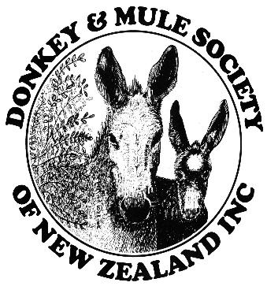
Application for sponsorship

Name of show:
Date of show:
Contact details of Show Secretary/Donkey class convenor:
Name:
Email:
Phone:
Address:

Signature………………………………………………….
Have you held donkey classes before? Yes/No
If so held many donkeys attended:
Amount requested:
Name of Account:
Bank Account number payment to be made to:

If the donkey/mule classes are cancelled sponsorship funds are to be returned to the Donkey & Mule Society of NZ Inc. Please contact the Treasurer via email should this occur

Office use: Please return form to: treasurer@donkey-mule.org.nz
Amount given Date payment made
Confirmation sent to show

